Figure 1 shows the median of emissions of trace elements from coal boilers in different eGRID sub-regions from bootstrapped trace element concentrations in coal and trace element partitioning fractions for different air pollution control devices.

This figure can be generated using the following code, found around line 550 of the “mass_bal_main_script.m”

%% Create median waste stream factors of trace elements for CFPPs by eGRID subregions

boot_plt_hg_egrid = innerjoin(boot_plt_emis_hg, egrid_subrgns);

boot_plt_se_egrid = innerjoin(boot_plt_emis_se, egrid_subrgns);

boot_plt_as_egrid = innerjoin(boot_plt_emis_as, egrid_subrgns);

boot_plt_cl_egrid = innerjoin(boot_plt_emis_cl, egrid_subrgns);

% close all;

for i = 1:size(subrgn_list,1)

subrgn_hg = boot_plt_hg_egrid(strcmp(boot_plt_hg_egrid.egrid_subrgn, subrgn_list{i,1}),:);

subrgn_se = boot_plt_se_egrid(strcmp(boot_plt_se_egrid.egrid_subrgn, subrgn_list{i,1}),:);

subrgn_as = boot_plt_as_egrid(strcmp(boot_plt_as_egrid.egrid_subrgn, subrgn_list{i,1}),:);

subrgn_cl = boot_plt_cl_egrid(strcmp(boot_plt_cl_egrid.egrid_subrgn, subrgn_list{i,1}),:);

% plot_med_emf_cdf_plt_subrgn(subrgn_hg, subrgn_se, subrgn_as, subrgn_cl, subrgn_list{i,1}) % create separate function for plant level modeling, some subtleties

end

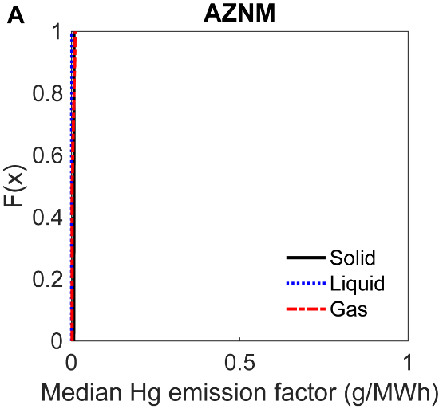

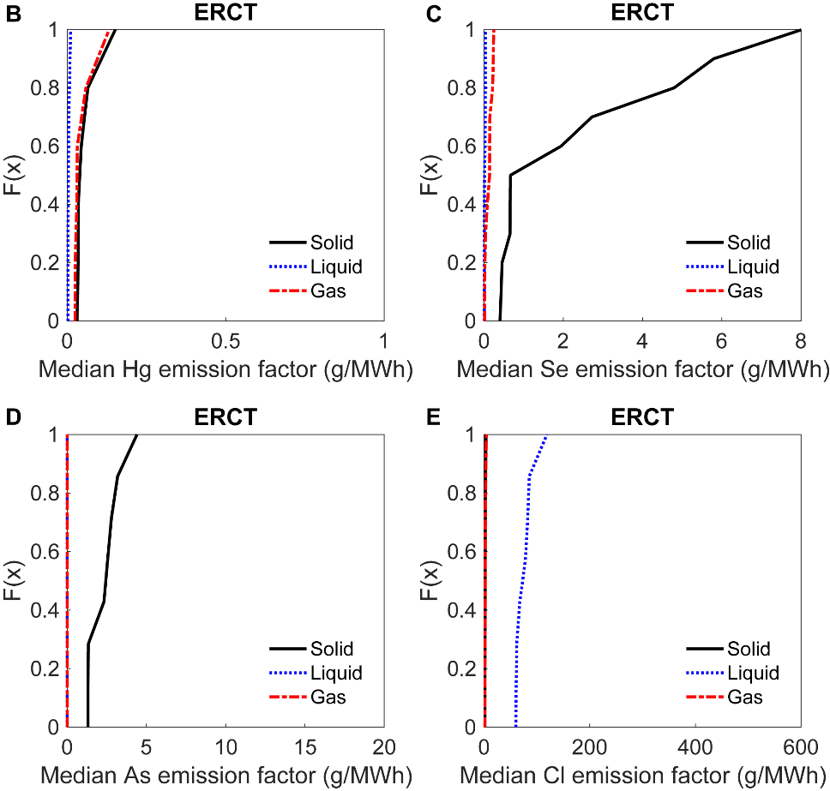

**Figure 1A**: Cumulative distribution functions of nonzero median trace element emissions into solid, liquid, and gas phases from bootstrapped coal concentrations and trace element partitioning fractions into solid, liquid, and gas phases by air pollution controls for each boiler in different eGRID sub-regions. (A) Emission factors in AZNM sub-region for Hg. (B-E) Emission factors in ERCT sub-region for B) Hg, C) Se, D) As, and E) Cl. Figure produced by the authors using data from COALQUAL, eGRID2014, Table S3, EIA-860, and EIA-923. [1], [2], [30], [31]

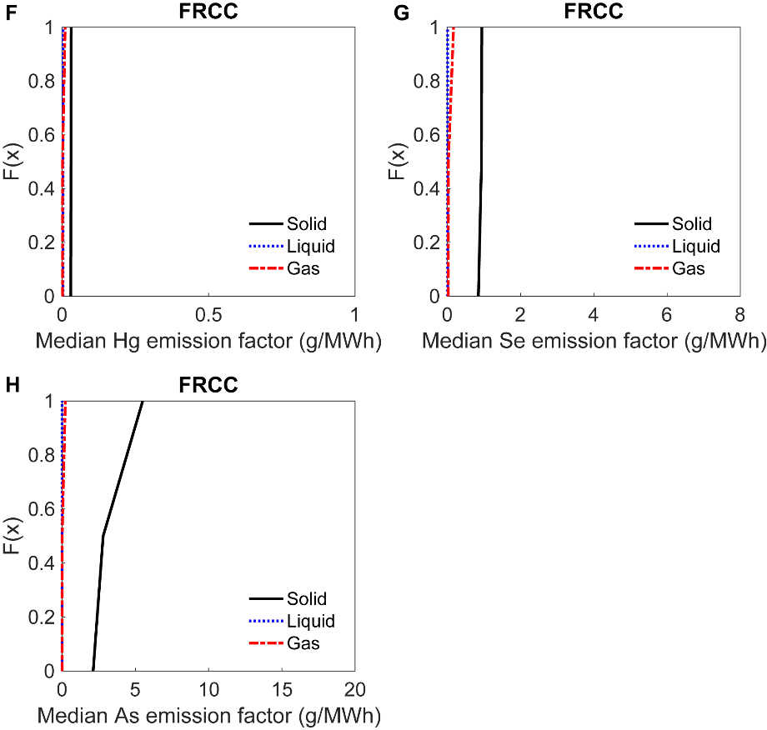

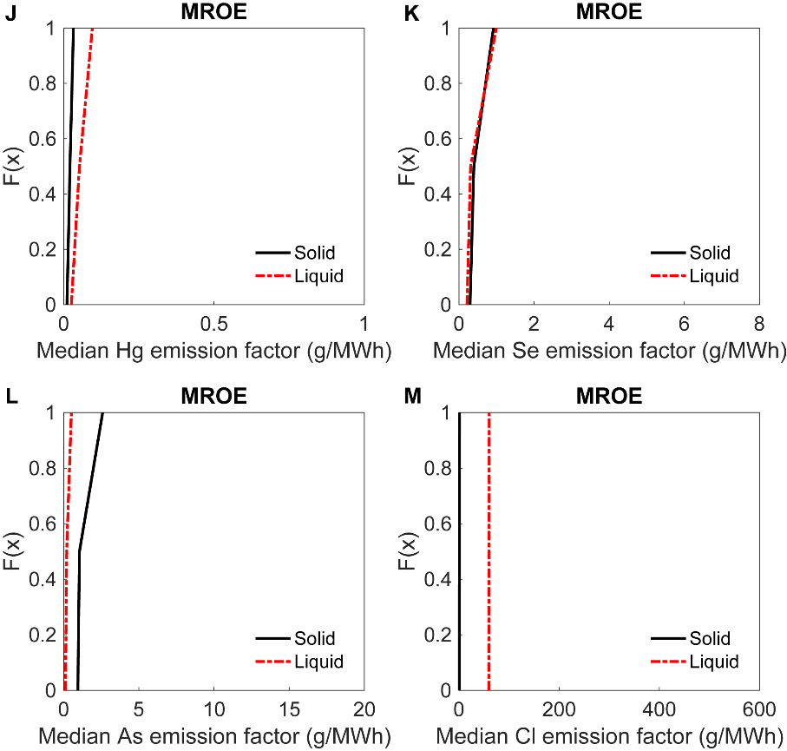

**Figure 1B**: Cumulative distribution functions of nonzero median trace element emissions into solid, liquid, and gas from bootstrapping coal concentrations in coal and solid, liquid, and gas partitioning of trace elements by air pollution controls at each boiler in different eGRID sub-regions. (F-H) Emission factors in FRCC sub-region for F) Hg, G) Se, H) As. (J-M) Emission factors in MROE sub-region for J) Hg, K) Se, L) As, and M) Cl. Figure produced by the authors using data from COALQUAL, eGRID2014, Table S3, EIA-860, and EIA-923. [1], [2], [30], [31]

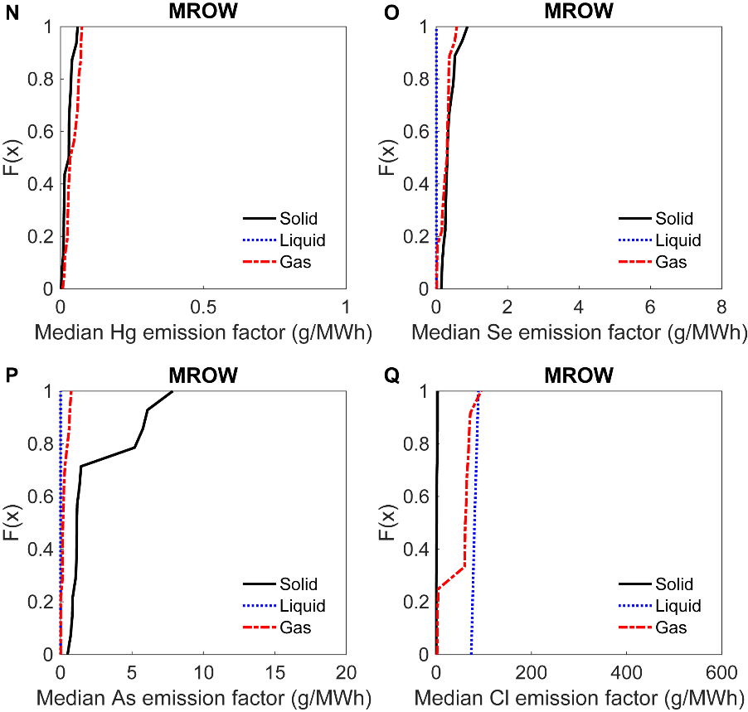

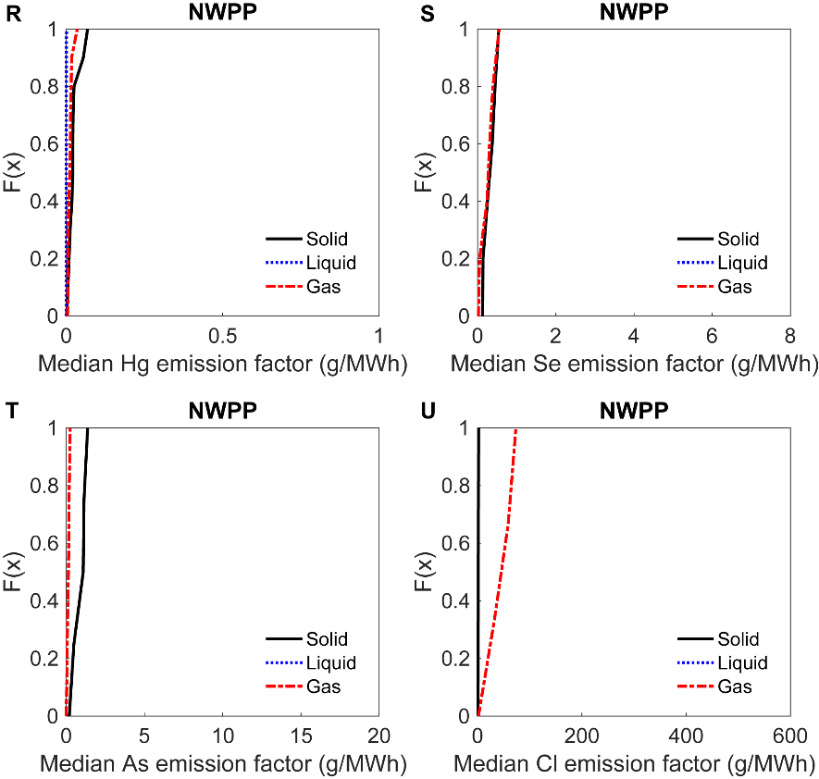

**Figure 1C:** Cumulative distribution functions of nonzero median trace element emissions into solid, liquid, and gas from bootstrapping coal concentrations in coal and solid, liquid, and gas partitioning of trace elements by air pollution controls at each boiler in different eGRID sub-regions. (N-Q) Emission factors in MROW sub-region for N) Hg, O) Se, P) As, and Q) Cl. (R-U) Emission factors in NWPP sub-region for R) Hg, S) Se, T) As, and U) Cl. Figure produced by the authors using data from COALQUAL, eGRID2014, Table S3, EIA-860, and EIA-923. [1], [2], [30], [31]

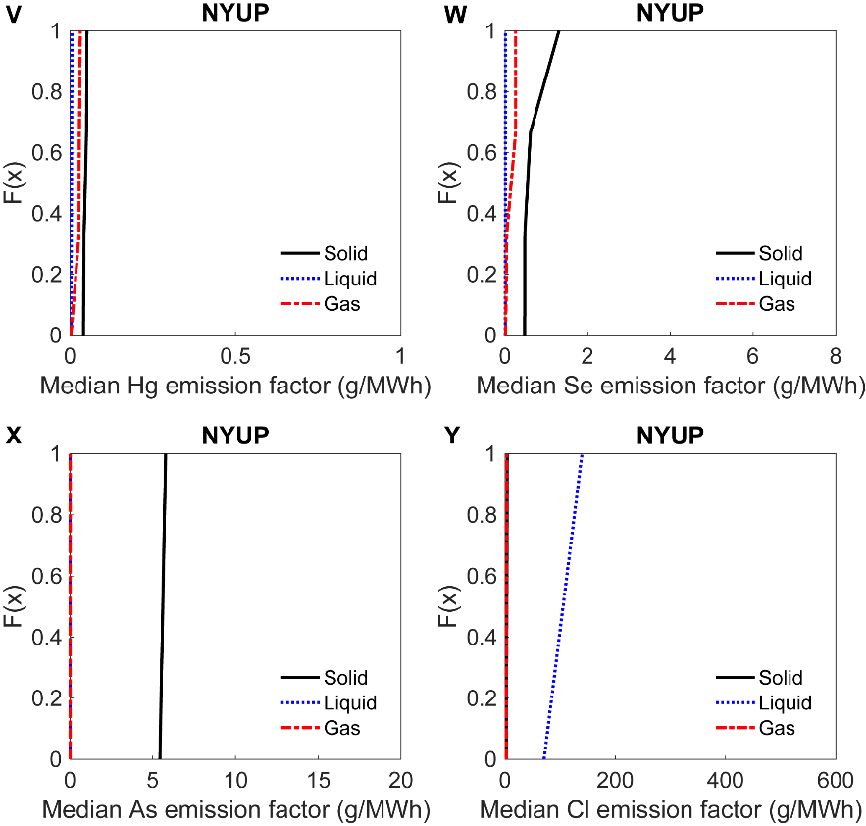

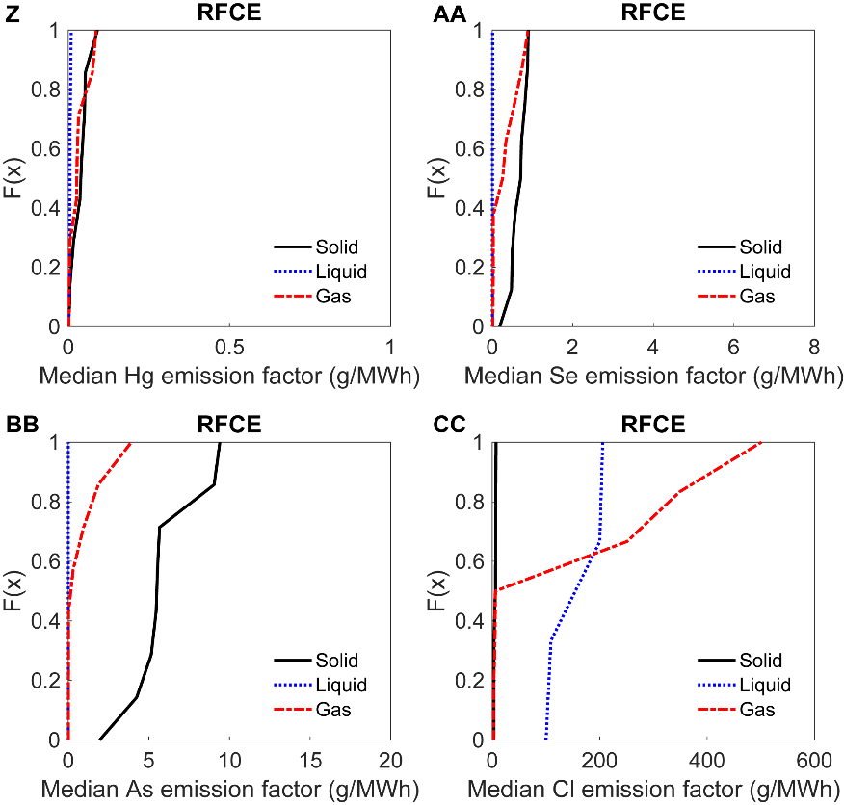

**Figure 1D:** Cumulative distribution functions of nonzero median trace element emissions into solid, liquid, and gas from bootstrapping coal concentrations in coal and solid, liquid, and gas partitioning of trace elements by air pollution controls at each boiler in different eGRID sub-regions. (V-Y) Emission factors in NYUP sub-region for V) Hg, W) Se, X) As, and Y) Cl. (Z-CC) Emission factors in RFCE sub-region for Z) Hg, AA) Se, BB) As, and CC) Cl. Figure produced by the authors using data from COALQUAL, eGRID2014, Table S3, EIA-860, and EIA-923. [1], [2], [30], [31]

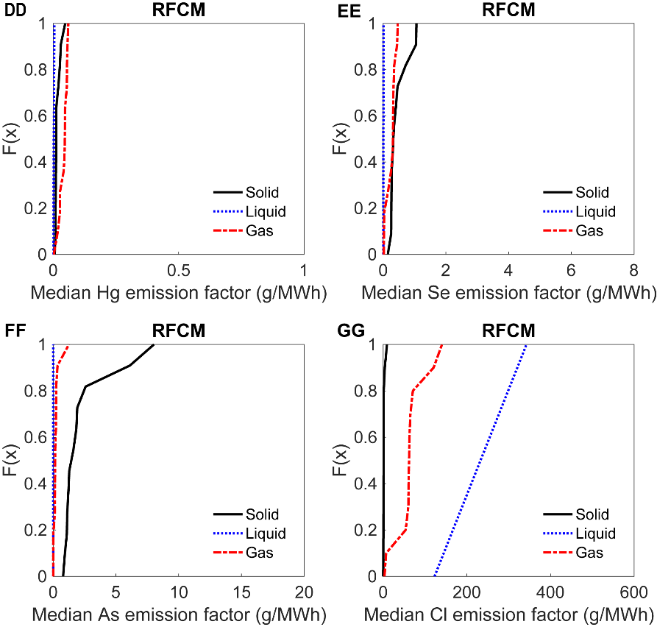

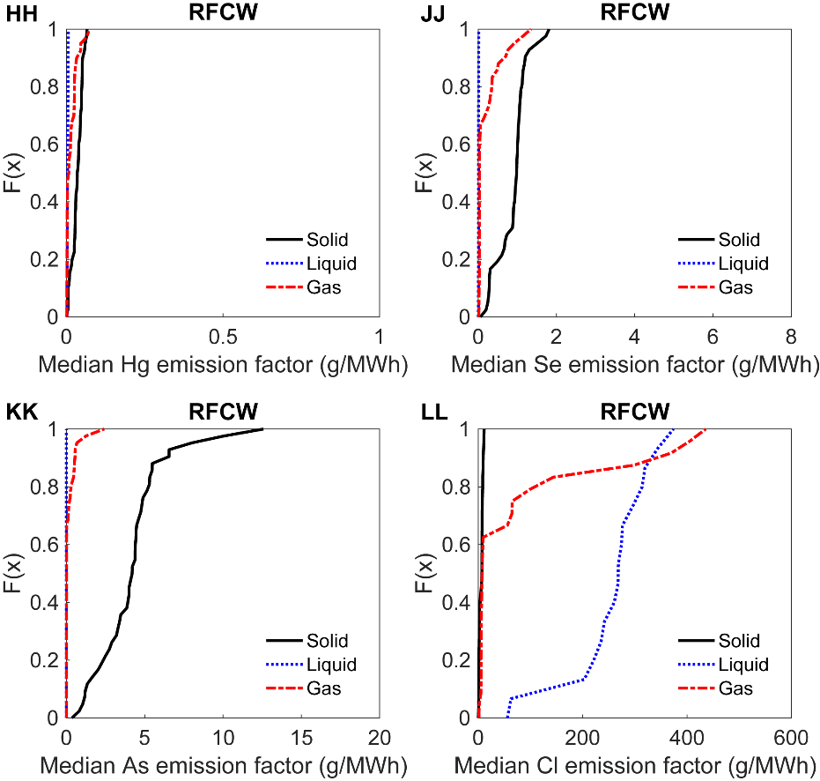

**Figure 1E:** Cumulative distribution functions of nonzero median trace element emissions into solid, liquid, and gas from bootstrapping coal concentrations in coal and solid, liquid, and gas partitioning of trace elements by air pollution controls at each boiler in different eGRID sub-regions. (DD-GG) Emission factors in RFCM sub-region for DD) Hg, EE) Se, FF) As, and GG) Cl. (HH-LL) Emission factors in RFCE sub-region for HH) Hg, JJ) Se, KK) As, and LL) Cl. Figure produced by the authors using data from COALQUAL, eGRID2014, Table S3, EIA-860, and EIA-923. [1], [2], [30], [31]

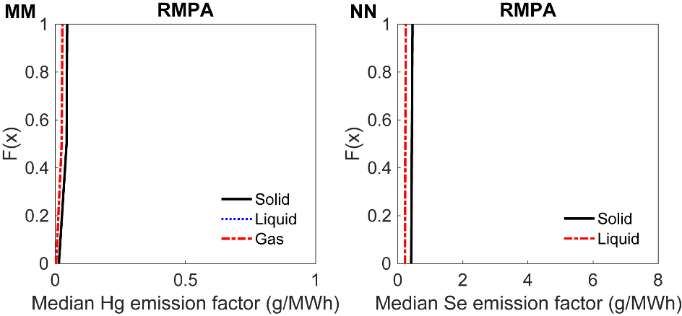

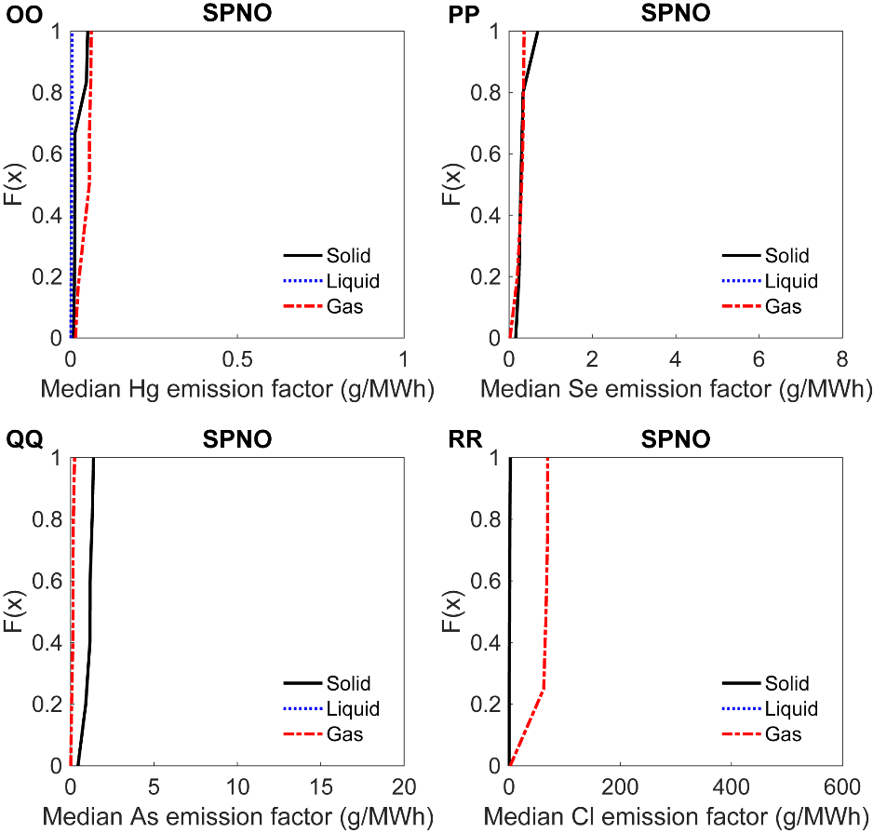

**Figure 1F:** Cumulative distribution functions of nonzero median trace element emissions into solid, liquid, and gas from bootstrapping coal concentrations in coal and solid, liquid, and gas partitioning of trace elements by air pollution controls at each boiler in different eGRID sub-regions. (MM-NN) Emission factors in RFCM sub-region for MM) Hg and NN) Se. (OO-RR) Emission factors in RFCE sub-region for OO) Hg, PP) Se, QQ) As, and RR) Cl. Figure produced by the authors using data from COALQUAL, eGRID2014, Table S3, EIA-860, and EIA-923. [1], [2], [30], [31]

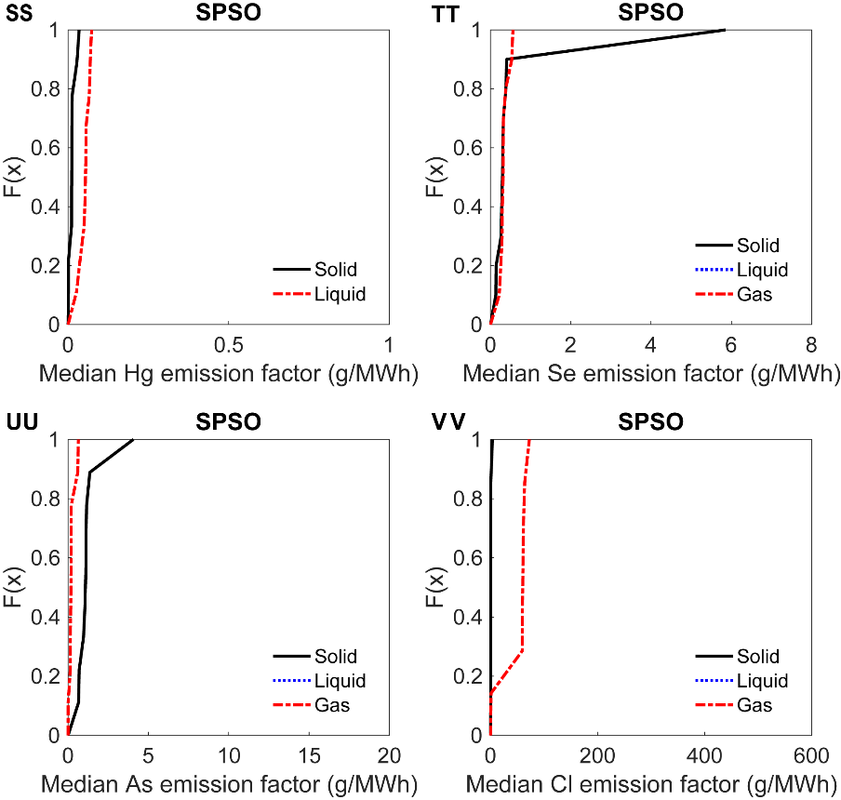

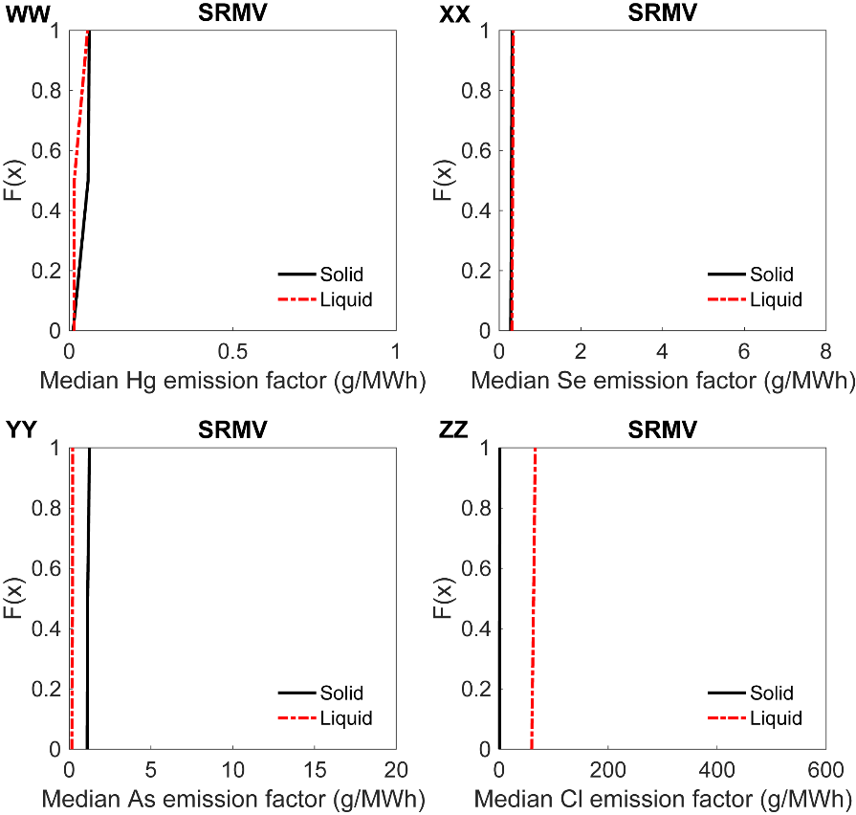

**Figure 1G:** Cumulative distribution functions of nonzero median trace element emissions into solid, liquid, and gas from bootstrapping coal concentrations in coal and solid, liquid, and gas partitioning of trace elements by air pollution controls at each boiler in different eGRID sub-regions. (SS-VV) Emission factors in SPSO sub-region for SS) Hg, TT) Se, UU) As, and VV) Cl. (WW-ZZ) Emission factors in SRMV sub-region for WW) Hg, XX) Se, YY) As, and ZZ) Cl. Figure produced by the authors using data from COALQUAL, eGRID2014, Table S3, EIA-860, and EIA-923. [1], [2], [30], [31]

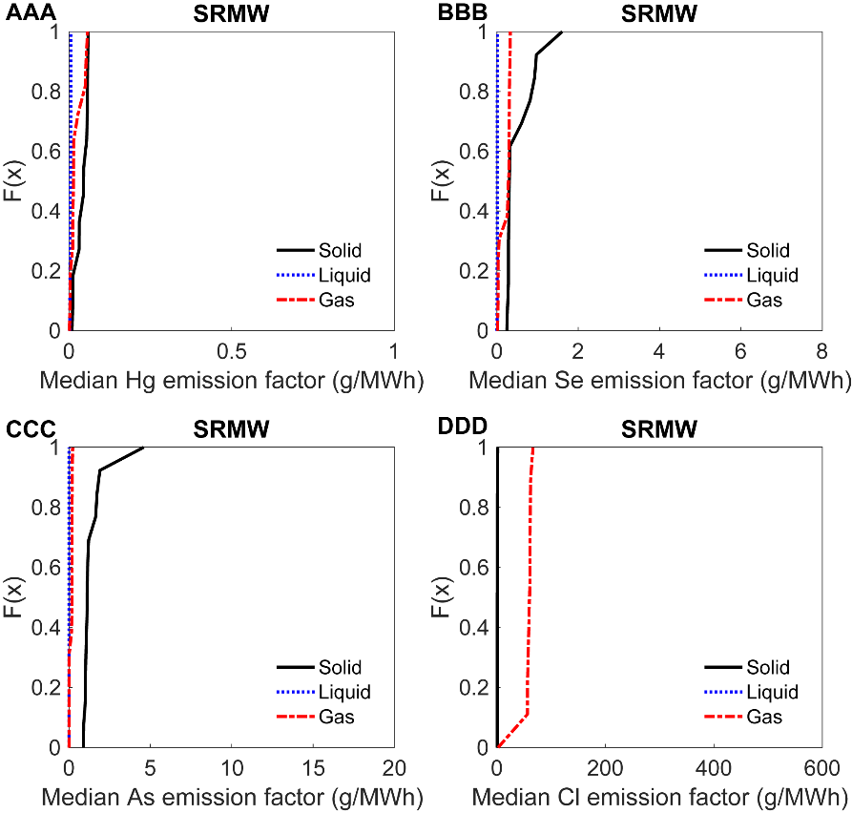

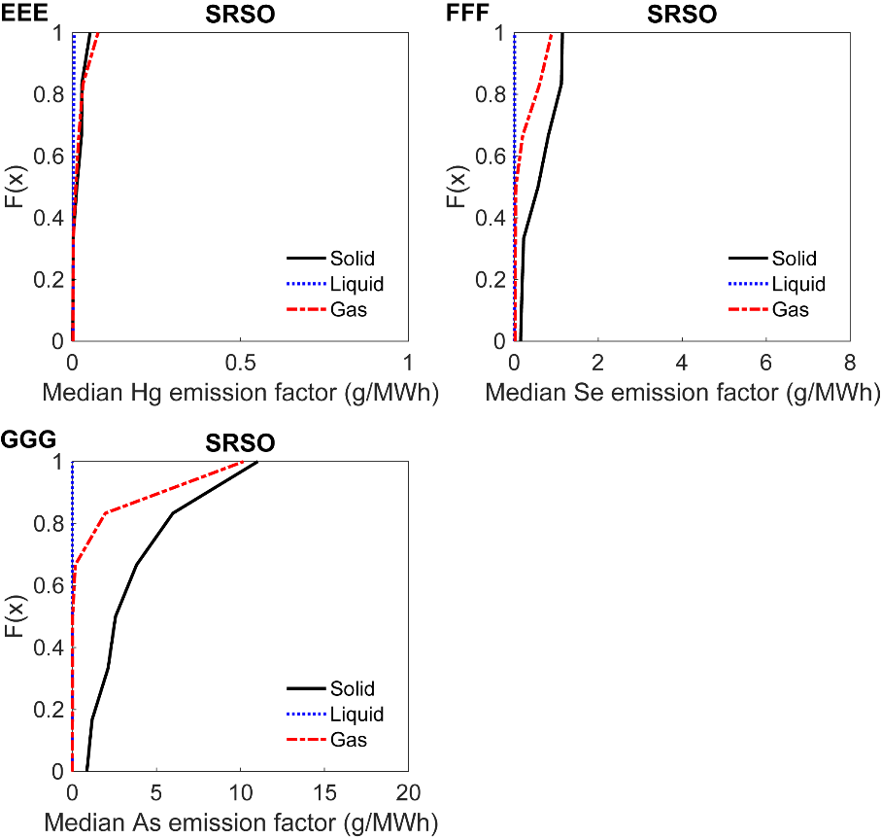

**Figure 1H:** Cumulative distribution functions of nonzero median trace element emissions into solid, liquid, and gas from bootstrapping coal concentrations in coal and solid, liquid, and gas partitioning of trace elements by air pollution controls at each boiler in different eGRID sub-regions. (AAA-DDD) Emission factors in SRMW sub-region for AAA) Hg, BBB) Se, CCC) As, and DDD) Cl. (EEE-GGG) Emission factors in RFCE sub-region for EEE) Hg, FFF) Se, and GGG) As. Figure produced by the authors using data from COALQUAL, eGRID2014, Table S3, EIA-860, and EIA-923. [1], [2], [30], [31]

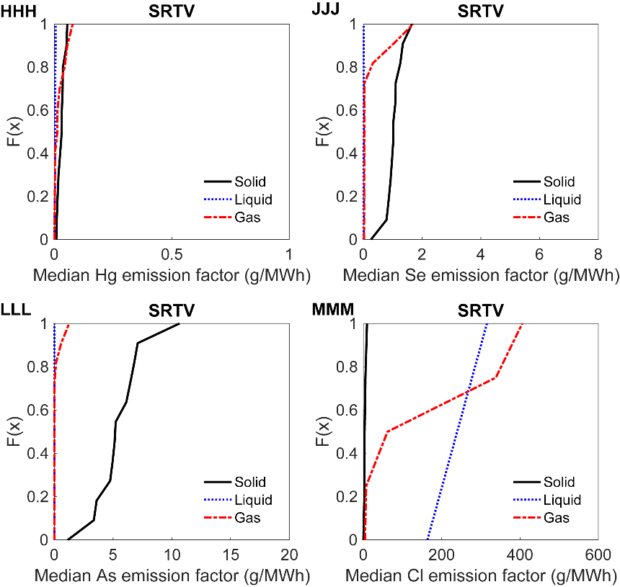

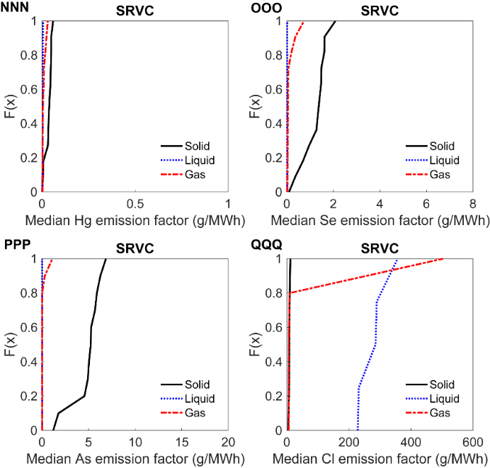

**Figure 1I:** Cumulative distribution functions of nonzero median trace element emissions into solid, liquid, and gas from bootstrapping coal concentrations in coal and solid, liquid, and gas partitioning of trace elements by air pollution controls at each boiler in different eGRID sub-regions. (HHH-MMM) Emission factors in SRTV sub-region for HHH) Hg, JJJ) Se, LLL) As, and MMM) Cl. (NNN-QQQ) Emission factors in SRVC sub-region for NNN) Hg, OOO) Se, PPP) As, and QQQ) Cl. Figure produced by the authors using data from COALQUAL, eGRID2014, Table S3, EIA-860, and EIA-923. [1], [2], [30], [31]